|  |  |
| --- | --- |
| **Networking Infrastructure**  Diploma in CSF/IT  Year 2 (2022/23) Semester 3 | Week **15** |
| **1.5** hours |
| **Windows 2016 Server :** **Resource Management** | |

## A. Objectives:

At the end of this practical, students should be able to:

* Configure Windows 2016 Server to share the following resources:
  + File Folders
* Configure **Share** and **NTFS** Permissions on shared folders.
* Configure Windows 10 client to access shared resources.
* Map the shared network folders to the appropriate users.

**B. Resources**

* VMware with Microsoft Windows 2016 Server (domain controller).
* VMware client running Windows 10.

(Form team(s) of 3/4 students. Each team will work on a server and 1 client.)

### C. Lab Setup

In this Practical, ensure the following before you proceed:

* Windows 2016 Server as a **domain controller** with Domain Name: NIT.com
* Windows 10 Client, login as NIT\administrator in the NIT.com Domain.
* The date and time on the PC (Host machine) is set correctly.

Settings for Server and Client should be as follows:

|  |  |
| --- | --- |
| TCP/IP Domain Name | NI**T**.com, **T** is the team number 1-8  (to be assigned by tutor) |
| Restore Mode Administrator Password | **p@ssw0rd** |
| Static IP address /Subnet mask | **For Server,** WinSvr2016_01**:**  172.16.**T**.**1**  **For Client PC,** NIclient**101**  172.16.**T**.**101**  **Subnet mask for all machines: 255.255.255.0** |

If you have already configured the above settings in the earlier lab, check that the IP/DNS settings are correct.

**On the PC where the Server is installed:**

Start VMware Player program.

Locate the Windows 2016 server VM (WinSvr2016_0X where X is your tutorial group number) that you have created in the earlier practical lesson.

Start the virtual machine-server. After the server is running, ensure the domain settings and IP settings are correct.

Login to the Windows 2016 Server with username “**administrator**” and password “**p@ssw0rd**”.

**D. Tasks:**

In this practical, we will complete the following tasks:

1. Create all the users and groups as listed in **Appendix A**

(**Please create all the users and groups in Appendix A before proceeding**)

1. These departmental **folders** shown below will be created in **Section E** according to their names in the **C:\User\Public folder**:

* **Public_NI1**
* **LOGISTICS**
* **DIRECTORS**
* **ADMIN**
* **TECHNICAL**

**Note:**

**Please do not create them now, actual steps starts in Section E**

1. Set the NTFS Permissions for the above folders as shown in **Table 1** below.

1. Share out the folders and set the share permissions. Share permissions are different from NTFS permissions.
2. The **Public_NI1** folder will be mapped to **drive Z:\** when the user login to the domain.

The **NTFS permissions** for **each** **folder** are as follow:

|  |  |  |  |  |
| --- | --- | --- | --- | --- |
| **File Folders** | **Logistics Group access rights** | **Directors Group access rights** | **Admin Group access rights** | **Technical Group**  **access right** |
| **PUBLIC_NI1** | READ | FULL CONTROL | READ | READ |
| **LOGISTICS** | FULL CONTROL | READ, WRITE |  |  |
| **DIRECTORS** | READ | FULL CONTROL | READ | READ |
| **ADMIN** | READ | READ, WRITE | FULL CONTROL | READ |
| **TECHNICAL** | READ | READ, WRITE | READ | FULL CONTROL |

**Table 1**

**Follow the steps below to complete the given tasks above.**

**E. Creating shared folders**

**On the Windows 2016 Server, do the following**

1. Login as **administrator**. In the Server Manager Dashboard, at the tool bar, click the Tools tab then select **"Computers Management”**.
2. In the tree, expand **System Tools**, expand **Shared Folders**, and then click **Shares**.
3. On the **Actions** pane, click **More Actions** and choose **New Share**.
4. The **Create a Shared Folder Wizard** appears, click **NEXT**.
5. **Browse** to c:\users\public\ and click **Make New Folder**.
6. Type in **PUBLIC_NI1** as the folder name and click **OK**. Click **NEXT**,
7. Leave the Share name as **PUBLIC_NI1** and click **Next>**.
8. In the **Shared Folder Permissions** page, select the **Customize permission** button and click the **Custom…** box.
9. Allow **Full Control** to **Everyone**. [This is setting the **Share** permission]
10. Select the **Security** tab. [This is setting the **NTFS** permission]
11. Click **EDIT**, then click **Add**.
12. Type in “**Logistics**” in the “**Select Users, Computers, or Groups”** page, and click **Check Names**.
13. Select **Logistics** **Group** and click **OK**.
14. Allow only the **Read** permission for the **Public_NI1** folder to the **Logistics Group**.
15. Click OK.
16. Similarly **repeat steps 11 to 15** to assign the access permissions for **Public_NI1** folder to the **Technical, Admin and Directors groups** as specified in **Table 1**.

At the end of permission setting for the **Public_NI1** folder, click OK, and Finish, then Finish to leave the wizard.

1. **Repeat steps 3 to 16 for the LOGISTICS, TECHNICAL, ADMIN and DIRCETORS** folders.

**F. Configuring Windows 10 Clients to access Shared Folders**

1.Login to the Windows domain from your Windows 10 client using one of the valid user accounts.

2. To access the shared folders that we have created, we could use **UNC (Uniform Naming Convention) path**:

Right click **Start** and then **Run**.

In the **Open:** textbox, type **\\<IP_address_of_server>\ and enter OK.**

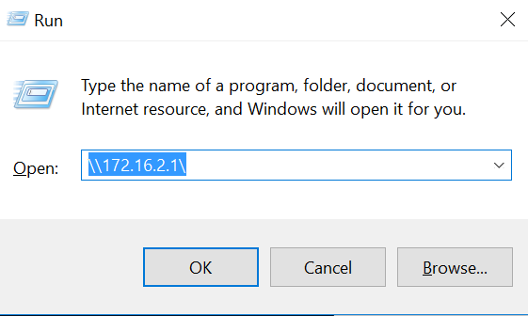

Alternatively, you can launch your Windows File Explorer and type in the UNC path to access, e.g. \\172.16.T.1\ and select ENTER

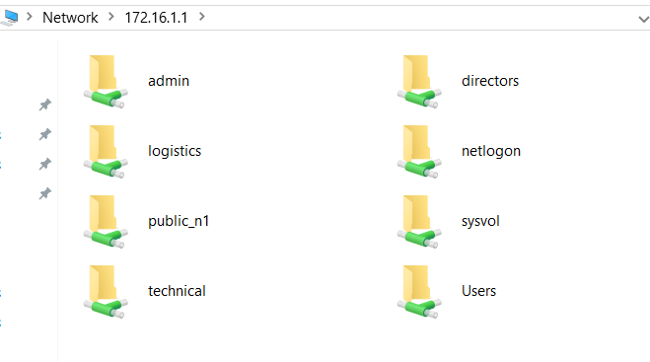

When the new window opens, double-click on the folder you want to access.

The folder's contents will now be displayed in a window. Your access in the folder **depends on the permissions given to the login user. Permissions will depend on both NTFS and share level permissions**

Test the permissions of the various shared folders by **using different user accounts** to access the shared folders. For example, as in Table 1, both ADMIN and TECHNICAL groups have no access to the LOGISTICS shared folder i.e. the folder will not appear.

Are the permissions set correctly as stated in the table of NTFS permissions? (Note that the share permissions of each folder have been set to “FULL CONTROL” for “everyone”.)

**Explore different combinations by changing both the share permissions and NTFS permissions to see the effective permissions for different groups for different share folders. [e.g. change share permission from Full Control for Everyone to Read]**

**G. Mapping a Drive Letter**

Once you have made shared drives or folders visible, you can open them up or explore them like any other folder. You can also **map them to drive letters**. Follow these steps:

#### 1. On the Windows 10 client, right-click a shared drive or folder you want to map, and then select Map Network Drive.

2. Check the box marked **Reconnect at Sign-in** to have your computer attempt to connect to the share on the remote computer whenever you login to your computer.

Choose a drive letter and folder, and then click **OK** or **Finish**.

Test this by re-login to the Windows 10 client. You should see the mapped drive under **this Client** in the Windows File Explorer.

**H. Configure Mapped Drive on the Windows 2016 Domain Controller**

We have learned how to map the drive on the Windows 10 client earlier but there is another way to map the drive by configuring the **mapping on the server instead**.

We will now map drive Z: to the **Public_NI1** folder. The steps are as follow:

* + - 1. Login to the Windows 2016 domain as an **administrator**.
      2. Use **Active Directory Users and Computers tool.**
      3. Right click on **any user account (e.g. Sales001)** in the different Organization units and select **Properties**. Click on **profile tab**.
      4. Under the home folder section choose "**Connect**". Select a drive letter (**Z:**)

Enter the path to the home folder as

**\\<IP address_of_your_server\PUBLIC_NI1** and then select **OK**

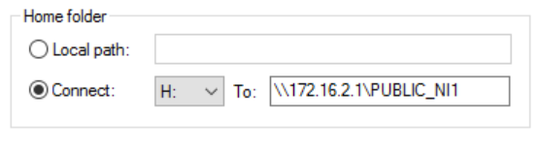

* + - 1. The next step is to login from the **Windows 10 client** using the user account (e.g.Log1) that you have just configured.

Do you see the mapped drive (Z:) under This VMware client?

***\*\*\*\* End of Practical \*\*\*\****

**Appendix A**

There is a **DIRECTORS** Group (OU) which consists of **4** users with the following username/password:

|  |  |  |  |  |  |
| --- | --- | --- | --- | --- | --- |
| **First Name** | **Title** | **Logon Name** | **Password** | **Access Times/Work Hours** | **Position Ends** |
| James | CEO | James | p@ssw0rd | No restriction | - |
| Mary | CFO | Mary | p@ssw0rd | No restriction | - |
| Simon | COO | Simon | p@ssw0rd | No restriction | - |
| Melvin | Sales Director | Melvin | p@ssw0rd | No restriction | - |

**Here are the user details for the 3 departments:**

**LOGISTICS** department/Group consists of **3** users with the following username/password:

|  |  |  |  |
| --- | --- | --- | --- |
| **First Name** | **Logon Name** | **Password** | **Access Times** |
| Log1 | Log1 | p@ssw0rd | No restriction |
| Log2 | Log2 | p@ssw0rd | No restriction |

**TECHNICAL** department/Group consists of **2** users with the following username/password:

|  |  |  |  |
| --- | --- | --- | --- |
| **First Name** | **Logon Name** | **Password** | **Access Times** |
| Tech1 | Tech1 | p@ssw0rd | No restriction |
| Tech2 | Tech2 | p@ssw0rd | No restriction |

**ADMIN** department/Group consists of **2** users with the following username/password:

|  |  |  |  |
| --- | --- | --- | --- |
| **First Name** | **Logon Name** | **Password** | **Access Times** |
| Clerk1 | Clerk1 | p@ssw0rd | No restriction |
| Clerk2 | Clerk2 | p@ssw0rd | No restriction |

**GROUPS**

|  |  |
| --- | --- |
| **Group name** | **Users** |
| Logistics | Log1  Log2 |
| Technical | Tech1  Tech2 |
| Admin | Clerk1  Clerk2 |
| Directors | James  Mary  Simon  Melvin |